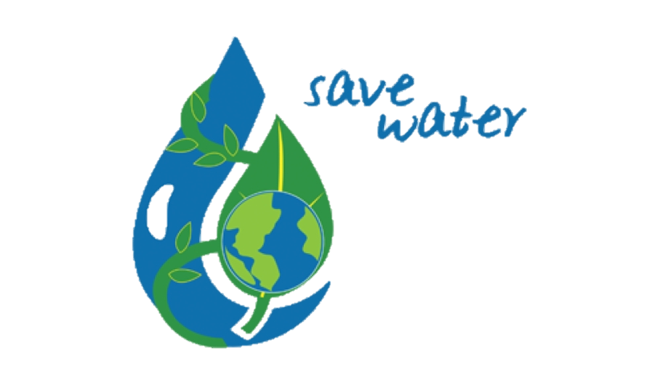

**OPPORTUNISTIC**

**PLAN**

**H²O**

**SUSTAINABILITY**

PARVEEN - SHRIN - HAJRA

DIVYA - MAHFAM

WATER SUSTAINABILITY PROJECT BY:

Contents

EXECUTIVE PLAN 3

COMPANY DESCRIPTION 4

1. Our Company’s Mission Statement 4

2. Company’s philosophy and vision 4

3. Company Goals 4

4. Legal Structure 4

EXTERNAL FACTORS 5

THE PRODUCT: 5

1. Our Product 5

2. Product Features and benefits 5

3. The problem our product solves 5

MARKETING PLAN 6

1. Market research 6

2. Barriers to entry 6

3. Threats and opportunities 6

CUSTOMERS 6

INTERNAL FACTORS 7

OPERATIONS: 7

TABLE : 8

FINANCIALS 9

1. Cashflow (Diagram) 9

2. Profit and loss 9

3. Balance sheet 10

4. Conclusion to finance 10

# EXECUTIVE PLAN

This document will entirely outline our business plan for 12 months, by highlighting both internal and external factors.

The product that we will be producing will operate in the technological market. Our product’s main purpose is to reduce water wastage in a household of no matter how many people live in it.

With the help of this 12 months executive plan, containing internal and external factors, will help us grow our business as well as will improve water sustainability in different industries.

# COMPANY DESCRIPTION

## Vision Statement Mission Statement Business Organization Company, PNG, 500x707px, Vision Statement, Blue, Business, Communication, Company DownloadOur Company’s Mission Statement

Our company, **H²O Sustainability**’s mission is to make people aware of water wastage and our commitment is to reduce it as much as possible. This mission will be achieved digitally, which saves a huge amount of money and time, and does the job effectively.

## Company’s philosophy and vision

The company H²O Sustainability, would love to see our customers using the product that we will be developing, to make sure we achieve this mission effortlessly. Our vision is fundamental and fixed to see technology fixing the issues that are unnaturally created.

## Company Goals

Our company’s main goal is to showcase our final product at the Innovation Fest within Birmingham City University and attract as many people as possible so that we can think forward to expanding our product’s sales. The best way to influence people is by explaining how our product is beneficial in terms of helping water sustainability.

## One Word Business Plan stock illustration. Illustration of funny - 50226271Legal Structure

Our company’s legal structure is composed by 5 people and the ownership is split equally by 20%. Within this partnership, every founder will be able to invest their knowledge and make sure our final product is perfect. The more experienced members we have, the more it will be beneficial for the business.

# EXTERNAL FACTORS

## THE PRODUCT:

## Our Product

Our prototype product will be designed to help reduce water waste in house’s. The product will be created with a pipe that will be connected to a tap, we will be using sensors to measure the water pressure in the tap. This will allow the pressure to be reduces if too much water has been used.

To manufacture the final product, our team will be working alongside BCU. We will be utilizing BCU’s resources to create and develop our prototype.

## Product Features and benefits

Our prototype will measure water waste data. This will be the main feature as the data can be used in many ways. We will gather the data that has been generated to our server where it can be seen by our customers. As our product will continue to develop, the data will be used in different ways, such as measuring how much water is saved annually.

The final product a sensor that will measure the water pressure in a tap. Showing the data will help give an insight into how water sustainability is important. It will allow customers to use our product in whatever way they deem fit.

## The problem our product solves

Water sustainability is growing problem that many water companies are trying to deal with. It is not clear on where the problem lies. With gathering the specific data, we want to support companies in recognizing where sustainability can be improved.

The prototype will be our first attempt into demonstrating how the data generated can be monitored and used. Our final product will allow our team to gather data and use it in many ways.

## MARKETING PLAN

## Market research

According to our research sustainability market is growing fast. Sustainability market size was valued at $10.32 billion in 2020 and is going to reach $74.64 billion by 2030. Our H2O sustainability project is designed to help this industry.

Our company is viewing strategy from the consumer’s point of view. We tried to use five principles of sustainable marketing which are: consumer-oriented marketing, consumer value marketing, innovative marketing, sense of mission marketing, and social marketing.

## Barriers to entry

We are facing lots of barriers to entry to this market. One of the barriers is its high cost which BCU is helping us with that. We also should try to make people familiar with H2O sustainability and all of its good impacts on the earth.

## Threats and opportunities

There is a big competition in the water sustainability industry. We are trying to do our best to accomplish all of our customer's needs and we will represent our project in innovation fest for them to see and decide whether it’s useful for them or not. We also tried to minimize the costs and offer a good price so they can purchase it easier.

## CUSTOMERS

The customers have a main part with our company due to the fact that our company has a mission. This mission is to make people aware of water wastage and how we can stop it from wasting. The customers help us because the more customers we have the more water we can save. We would also like to think about our target audience in much more detail. We believe that not just adults should help water wastage it should be the younger generation that can help us too. The younger generation has a huge impact on the water wastage. This is because whilst being young children waste a lot of water which they believe is okay but in reality its bad for the environment so if we engage more of the younger generation involved in our mission we can help make a change. This is a very challenging mission because it’s going to take a lot of work to do. We believe that by using social media we can get more people involved.

# INTERNAL FACTORS

## OPERATIONS:

|  |  |  |  |  |
| --- | --- | --- | --- | --- |
| MILESTONES | PRODUCT | MARKETING | BUSINESS | COSTS |
| *Q1*  *Decision of the product.*  *2 Weeks* | Confirming the chosen product to be developed. | Informing the BCU project department, of the materials that we will use in the upcoming weeks. | Agreement of purchasing the right tech components and materials. That will meet the client needs. | £1k |
| *Q2*  *Developing stage of the Product*  *6 Weeks* | New programing to be applied to the Arduino, including the development of the product.  Applying the sensor onto the tap | Codechef Website supports any format of programming language.  The clients will be able to see our progress from time to time. | Our investors will see our basic design of the structure of the product, would look like which would be labelled for the parts that we will use. | £7k |
| *Q3*  *Testing of the product & Meeting*  *3 weeks* | After the first testing of the completion of the integrated programming software. Arduino IDE software used to run the entire test coding. | Once that is completed we will present the test to the BCU project collaborators. | Ensure for any improvements/ designs.  Check each member of the team tasks is executed.  Apply final new changes for the final stage, after our feedback from the meeting. | £10k |
| *Q4*  *BCU Steamhouse*  *1 week* | From this point all member of the team will collaborate together with the client. This will give us chance to present the finalization of our product. | The clients will see our product operating live in their presence. We also will have a presentation which would be the marketing of the completed product. | This is a good opportunity or achievement when we collaborate with business investors from different areas of IT. Which would be a good benefit for future projects. | £15k |

An Operations table is an effective plan to use, this is because when you look at the table that is created. Every member of the team, is able to easily navigate their plans and stages a few months at a time. But most importantly know, when the right time to build a product.

* Investors & Customers - The investors and customers would be the clients who we will present our prototypes and would hopefully invest into our product.
* Media – After the completion of our water sustainability product, an image/video will be posted on LinkedIn where many business IT industries and students will see the display of our product.
* Founders/ Employees – The BCU girls project team are the official founders & employees of five members of the innovation team.

## TABLE :

|  |  |
| --- | --- |
| SWOT Analysis | |
| STRENGTHS | **One of the main key point skill in strength is different use of skills sets. Meaning that each member of our team, has acquired many different skills that we can learn from each other. For example programming, computer science and computer system skills that we would have learned before.**  **With five members of our team we are able to, gain particular knowledge information when it comes to designing our product. This is because we are able to teach one and other how the skills are being implemented.** |
| WEAKNESS | **The main weakness that appears for our team, would be the absent of members of the team. This can be a worrying issue, because if it comes to developing a product, and one member of the team is absent. This could affect the timely milestone schedule of our timeframe.** |
| OPPORTUNITIES | **Our goals in our team is to make sure that we work together efficiently, by communicating interactively in MS teams. This allows us to know, what next steps to take.**  **Our product that we are going to develop soon, will be presented at the BCU STEAM house that is provided for us students will give us the opportunity to experience the innovation of our project.**  **If the water sustainable product becomes a success of development. This can be a huge opportunity, to make a difference of water waste that happens into people household. From there it will lead onto the next opportunity, companies would most likely be interested to product’s that are related to prevent climate change or reducing water waste.** |
| THREATS | **There are some potential threats that may occur in our team. Such as with the covid crisis it will take time to order certain component’s to arrive especially if the components are coming from outside in the UK.**  **Costs of certain type of components, can be costly which would depend of what we will purchase. Also, with a lot of economic prices of many things are gradually increasing in future.** |

FINANCIALS:

## Cashflow (Diagram)

## Profit and loss

Below is a table that we have created it’s based on the profits and losses.

## Graphical user interface, text Description automatically generatedBalance sheet

## Conclusion to finance

Throughout this project we all have to think about our finances and how are we going to deal with them. Due to COVID there is a lot of prices going higher day by day. So we all know that this project is going to cost a lot more than what we thought of we also have a budget. We will all try and follow the budget so it can help us. Finance this a very important topic that we discuss about a lot this is because if we talk about our finances in much more detail we know how much were spending.